
Year 8 Mini Test
Term 4 2017
Area, Perimeter and Volume
Resources Allowed
- 1 A4 page of notes
- Calculator
Name:_____________________________ Score:____/ 25
- [1, 2, 2 = 5 marks]
Find the perimeter of the following shapes. Show your working clearly.
Shape | Working and Answer
a)
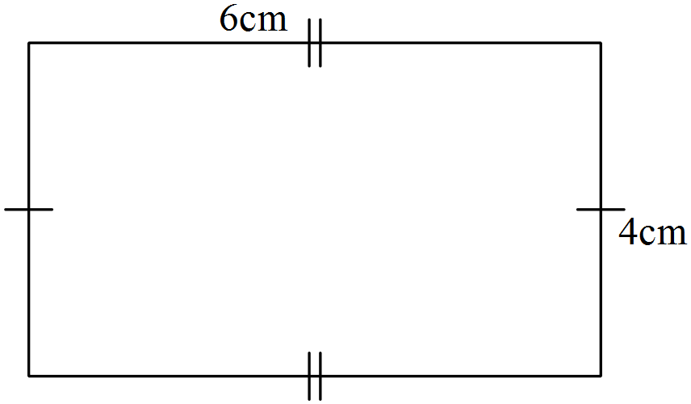

b)
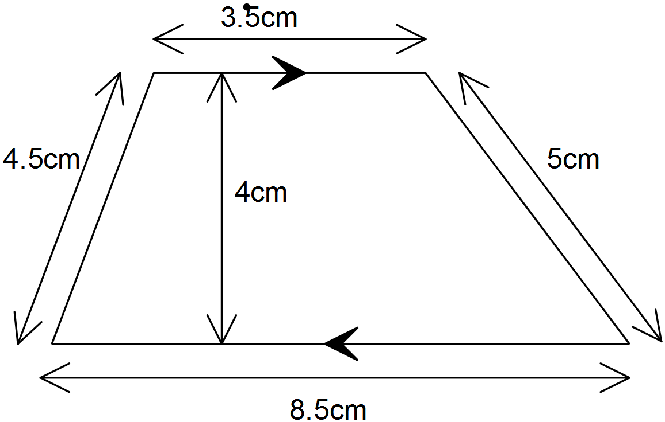

c)

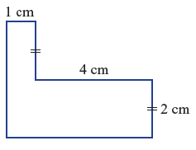

- [2,2,2,2 = 8 marks]
Find the area of the following shapes. Show your working clearly and give your answers correct to two decimal places when necessary.
Shape | Working and Answer
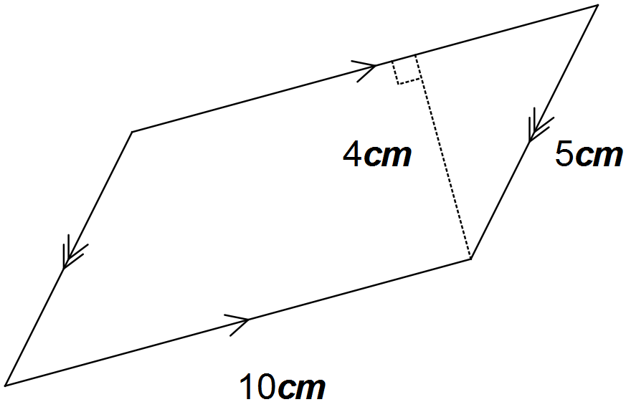a)

b)
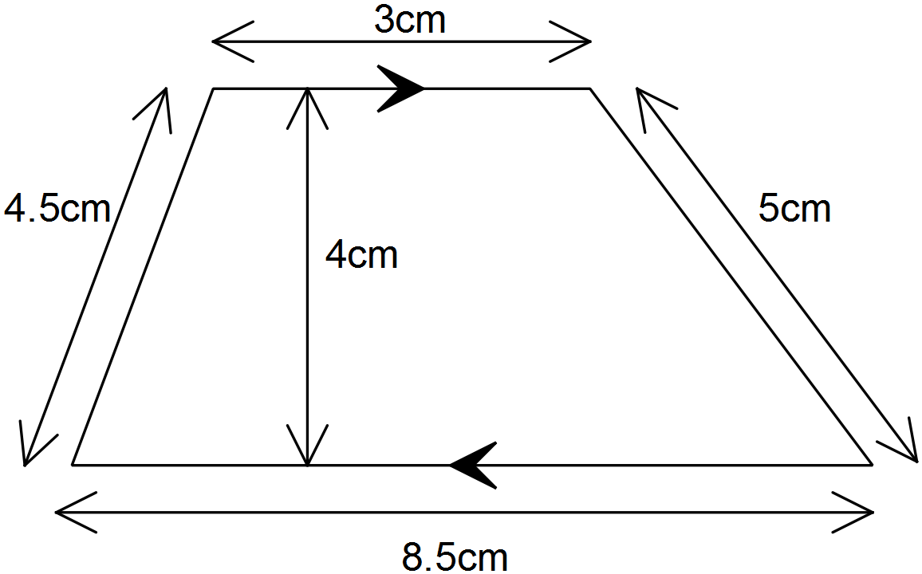

c)
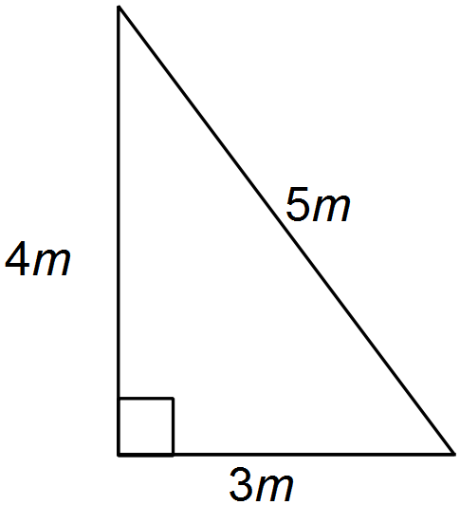

d)
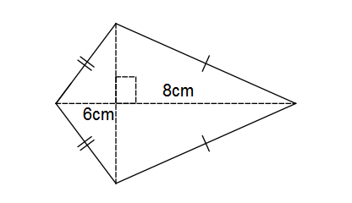

- [2,2, 3 = 7 marks]

Calculate the volume of these prisms:

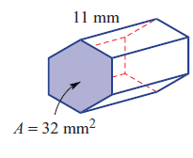

b)
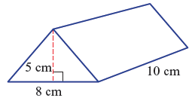

c) A hollowed out section of square drainpipe made of 20mm thick steel.
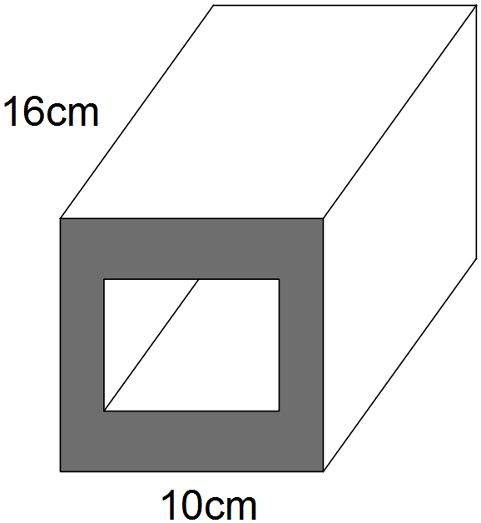

- [1,1,1,2 = 5 marks]
The perimeter of a rectangle is 36 m.
- Draw a rectangle with this perimeter and mark in a possible length and width.

- Find the area of your rectangle.

- Your rectangle is not the only possible rectangle with perimeter 36 m. State one other possible length and width that would give a perimeter of 36m.

- What is the largest area your rectangle with perimeter 36m could be? Show working.

